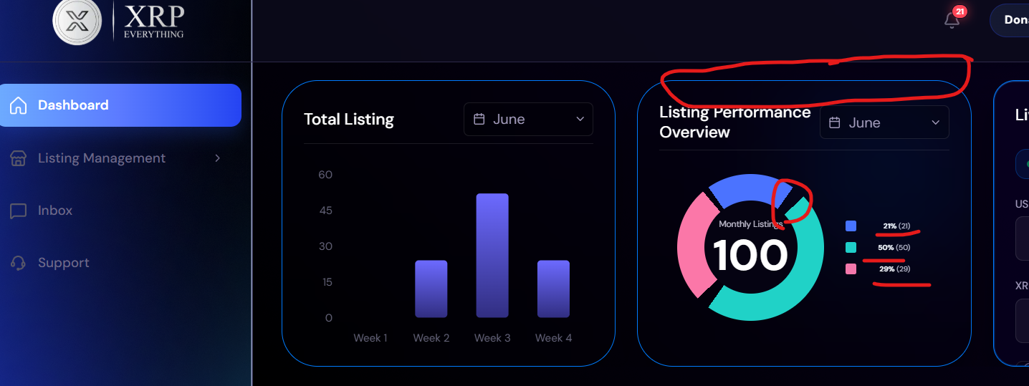

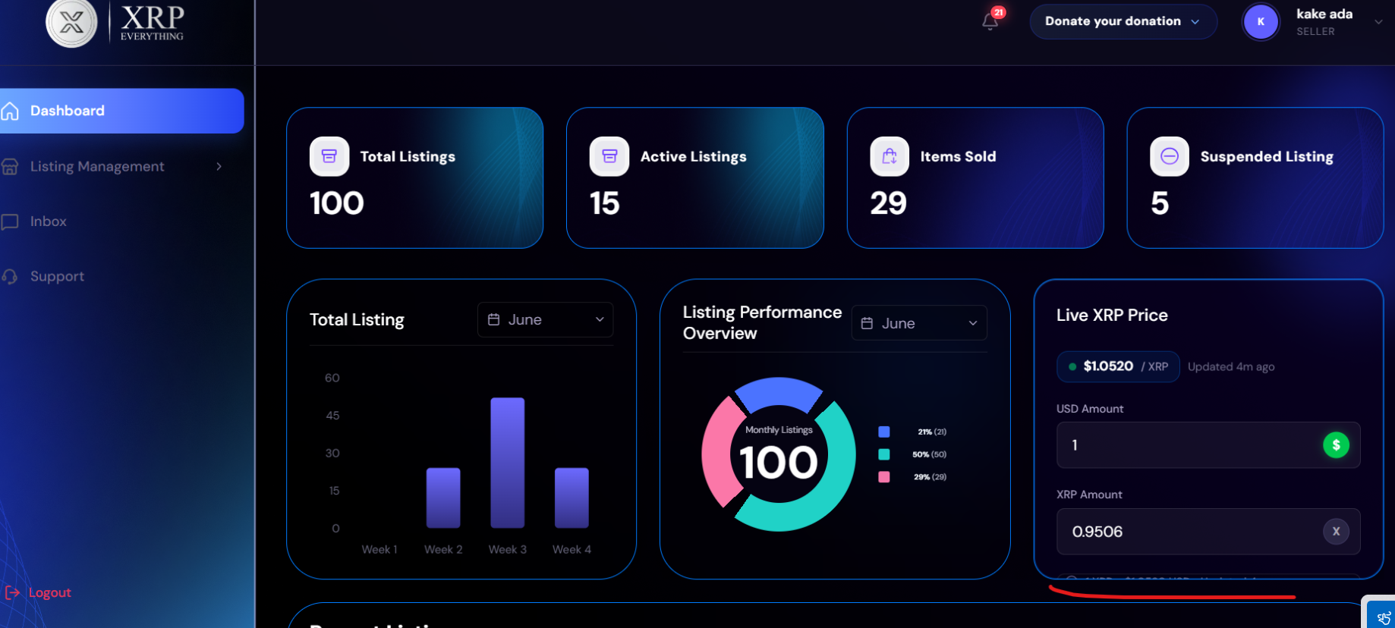

Session timeout
No notification to seller, when admin rejected the listing
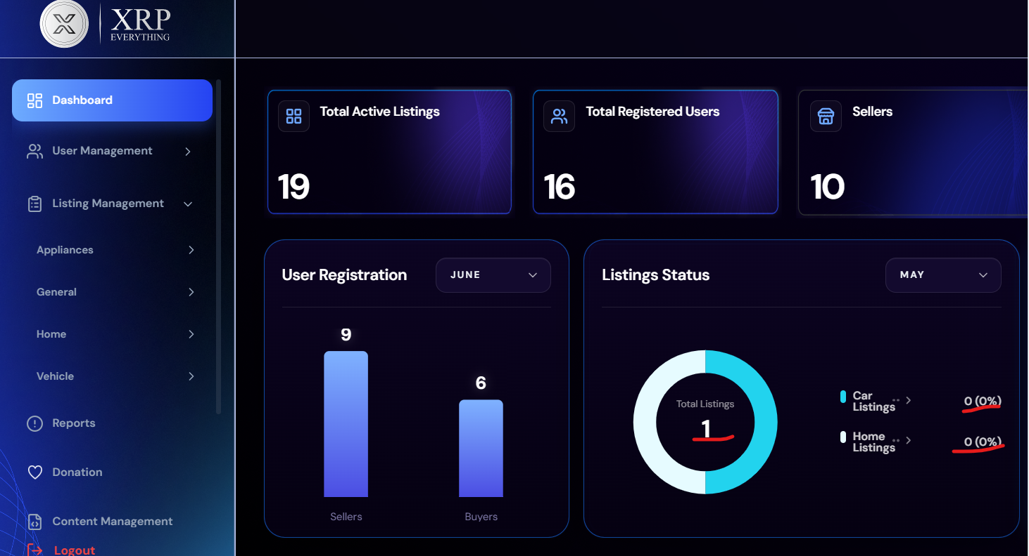

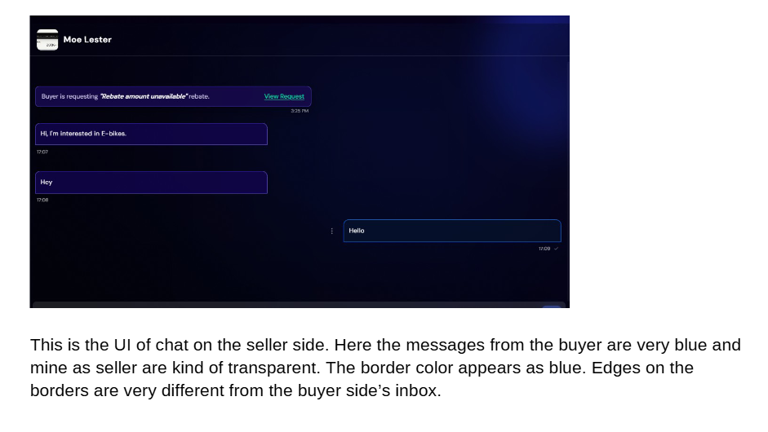

Border consistency issue on every panel

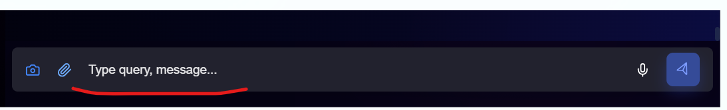
On Admin, placeholder color should be dim in color

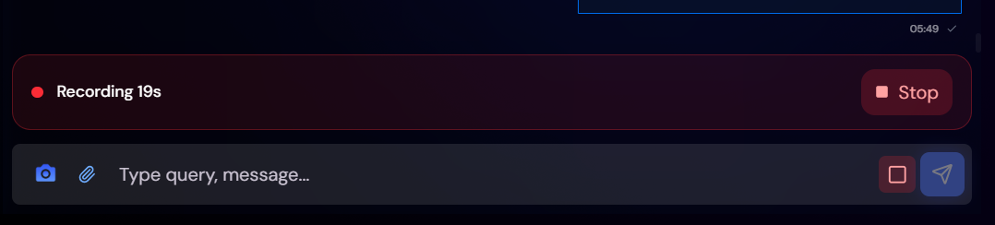
Recording should be consistent or not ?

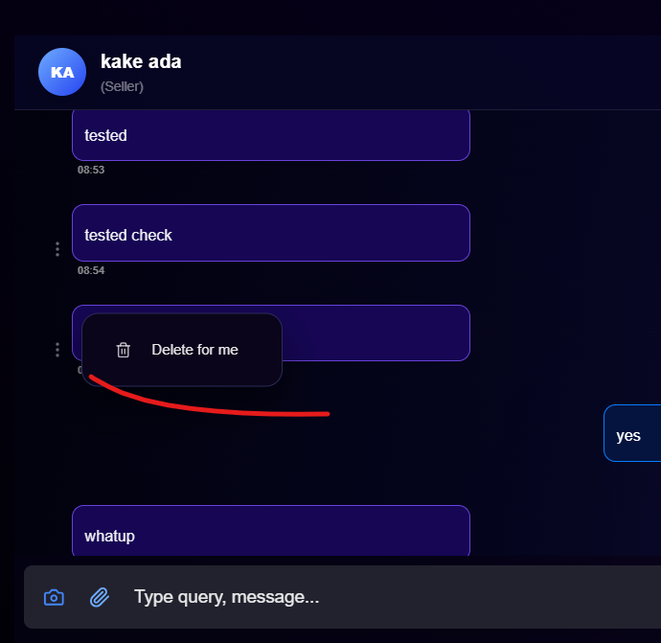
On admin panel
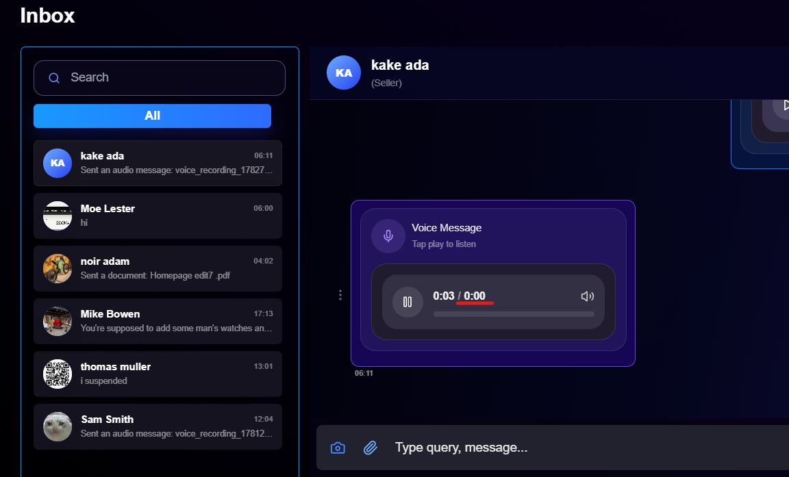
On Admin Panel, issue from seller

Double push notifications on every panel
Notification appears when the screens are closed
When seller edit the listing, listing should be display in top on admin panel

